**Circuit diagram**

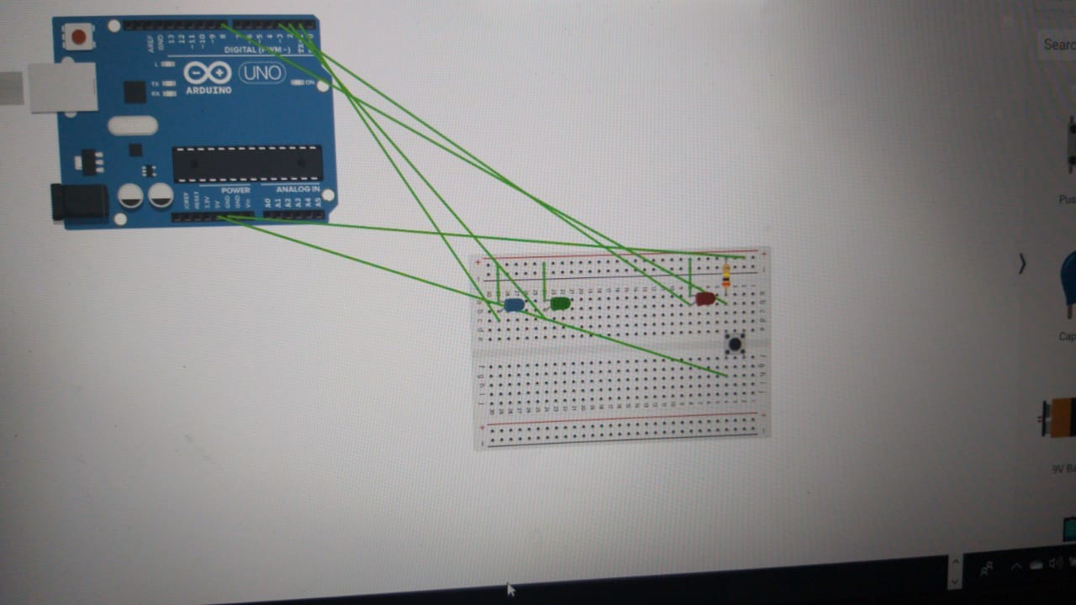

**Aim**

**Design a dice that displays a a.Red background when 6 comes up b.Green background when 4 comes up c.Blue background when 2 comes up**

**Learning and Observations**:

The instructions are given to the arduino Board by performing programming in the computer. The language used in this experiment is C. Arduino is used to make the applications more accessible which are interactive objects and its surroundings. It provides the genuine instructions to the element placed in the breadboard according to the programming done in the software.

**PRECAUTIONS**:

1. Take care the the programming because the wrong programming can cause problems in the software.

2. MAke sure that the wires and connections are properly connected and are tight.

3. The order of positive and negative terminals should be correct.

**PROBLEMS AND TROUBLESHOOTING**:

1. Perform the practical after having some practise the concepts of programming language deeply.

2. Place the hardware properly or use the hardware(Breadboard) properly.

3. Check the wires before executing the program. Make sure that the connections are tight properly.

**LEARNING OUTCOMES**:

From this experiment, we get to know about how to make **an Design a dice that displays a a.Red background when 6 comes up b.Green background when 4 comes up c.Blue background when 2 comes up**

got very deep information about the circuits, breadboards, Audrino and programming